

**Project Report**

|  |
| --- |
| Project Title: IUS Campus Network System. |
| Course Name: Network & Server Administration Lab. |
| Course code: CSE 4278-0612. |

Submitted By:

Abdur Rahman Roky

212010078 (10th batch)

Department: CSE.

Submitted to:

Sanjida Afroz Shimu

# (Lecturer, CSE)

**ABSTRACT:**

Networking connects computers for secure and efficient information sharing. This project focuses on designing a secure campus network while optimizing resource sharing, including files, applications, and software. Networking enhances security, efficiency, and cost-effectiveness. Key devices like switches and routers enable data transfer via wired and wireless technologies. Collision detection mechanisms prevent data conflicts, ensuring smooth transmission. The project aims to develop a cost-effective network using LAN, WAN, VLAN, and routing protocols while minimizing expenses. Cisco Packet Tracer is used for network design, with hardware implementation providing practical experience in network development.

**INTRODUCTION:**

A wired campus network is essential for education, giving students and teachers access to resources and seamless communication. As demand for real-time information grows, traditional cable networks face limitations. Wired networking ensures stability, mobility, and flexibility, complementing existing infrastructures. The integration of network technology enhances teaching and research, overcoming cable networks' mobility shortcomings while ensuring continuous and secure connectivity.

**Project Statement:**

This project simulates a university campus network using wireless technology, dividing it into Main and Branch Campus segments. The goal is to ensure efficient, mobile connectivity while providing DNS, Email, and HTTP servers for resource optimization. Security protocols enhance network reliability. The campus network supports internet access, data sharing, and web services, ensuring stable and efficient communication essential for academic activities.

**Tools or Equipment to use:**

1. Cisco Packet Tracer.

**Devices Used in The Network:**

**Table 1: Devices names and quantity**

|  |  |
| --- | --- |
| Devices | Quantity |
| Router (2911 PT-Empty) | 3 |
| Switch (2960 24PT) | 10 |
| Server - PT | 3 |
| PC - PT | 10 |
| Switch (3560) | 2 |
| Printer | 9 |

*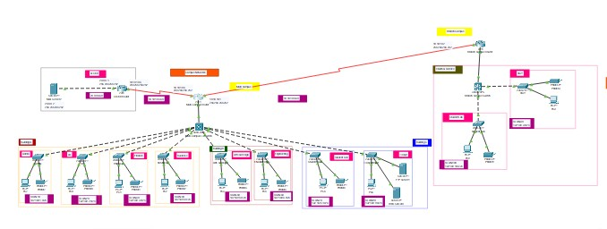***Topology****Diagram:**

**Main-Campus:** 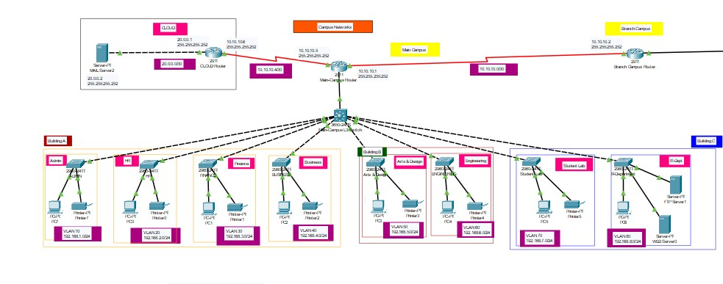

**Branch campus:**

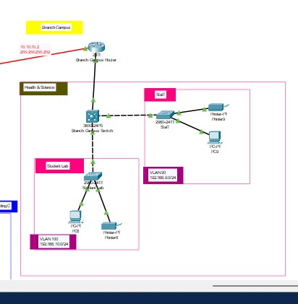

**Command-line****interface**

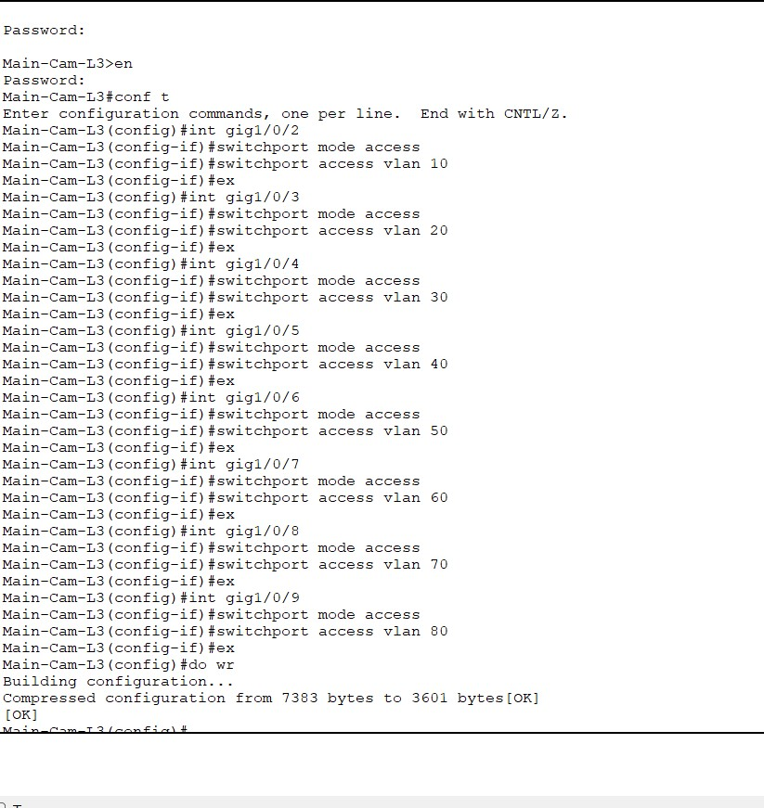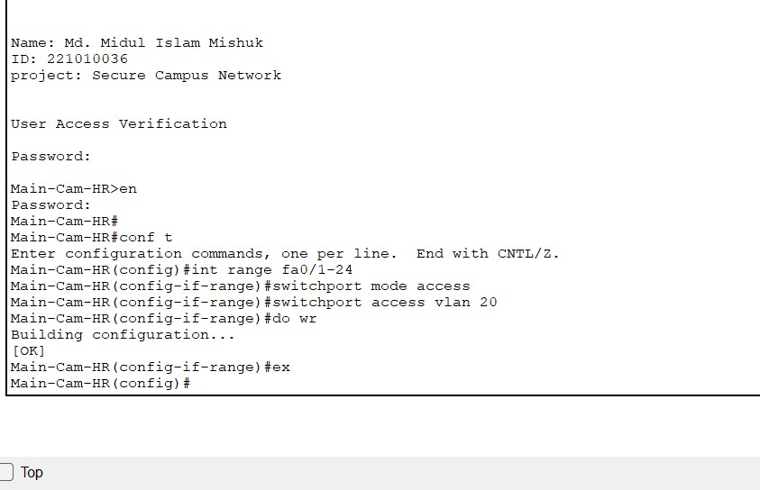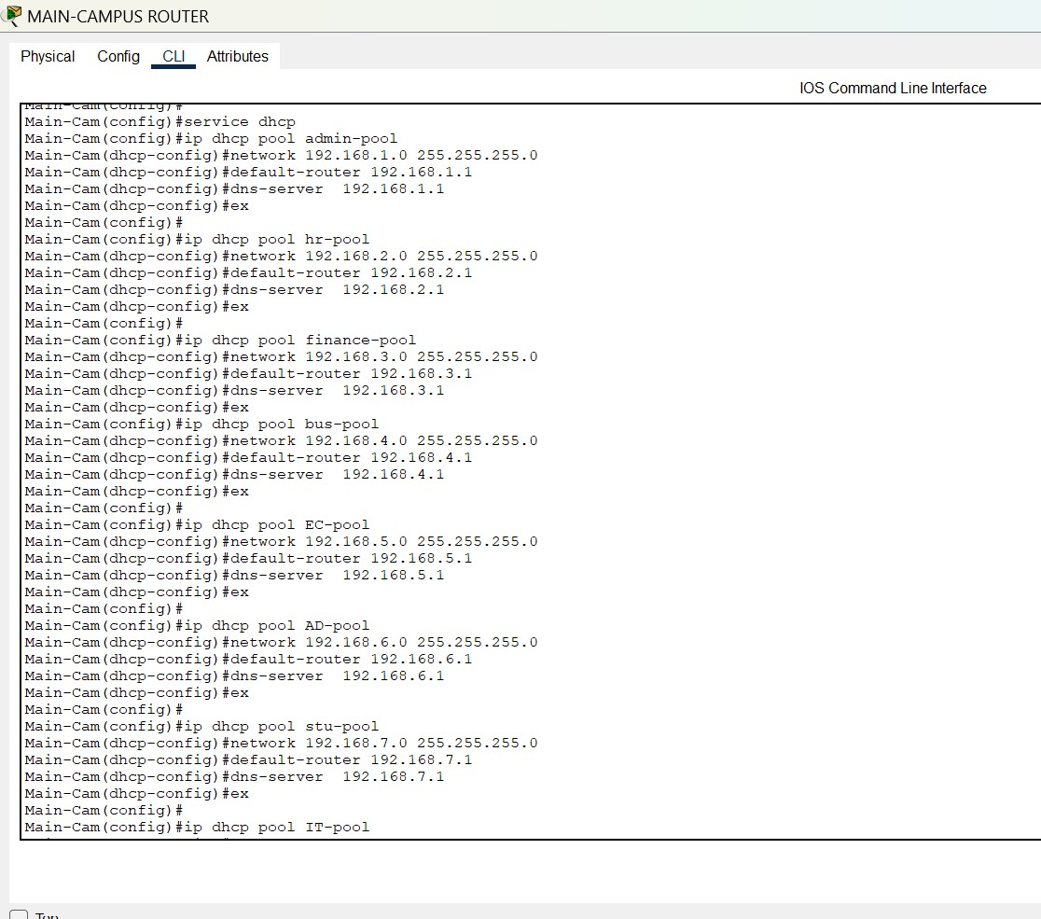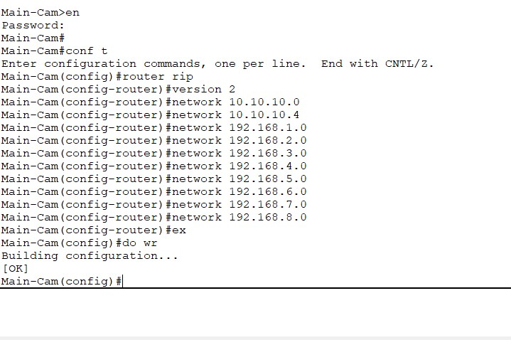

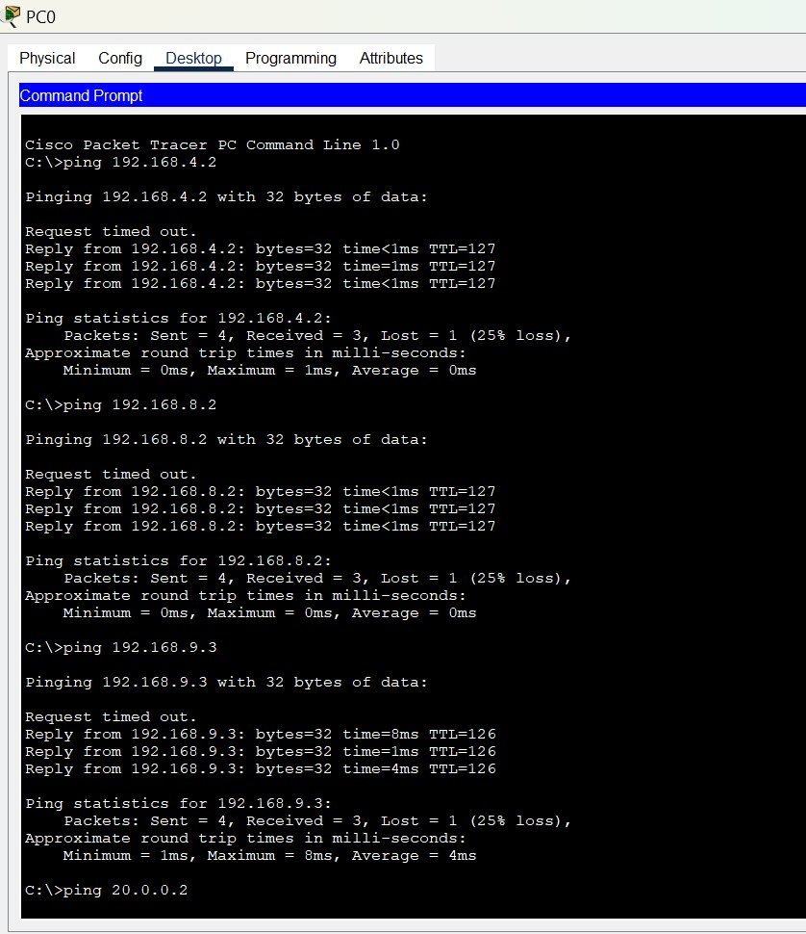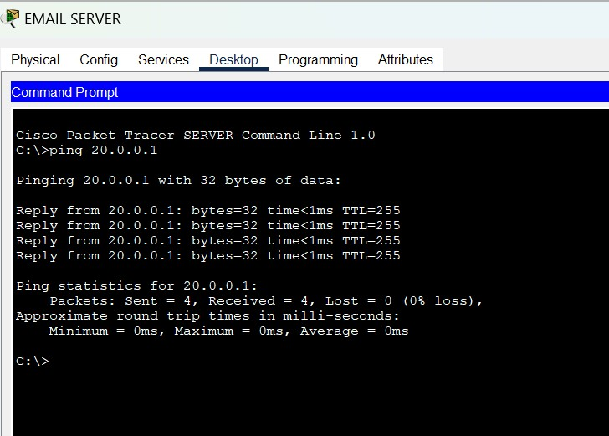 **Ping All Device**

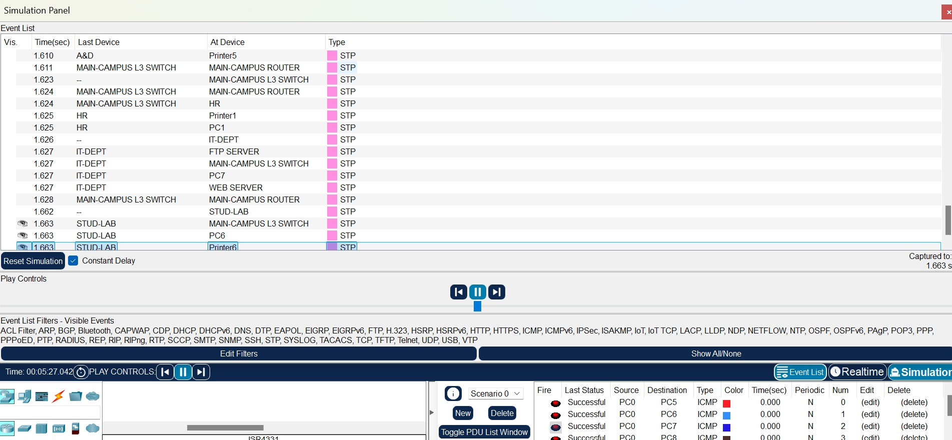 **Simulation**

# **Conclusion**

The project successfully addressed key questions regarding the performance of the campus network system. It demonstrates a scalable, secure, and efficient network topology for IUS University, meeting the functional and security needs of a modern educational institution. By implementing VLANs, dynamic IP addressing, RIPv2 routing, and SSH-based secure access, the network ensures seamless communication among faculty, students, and staff across multiple campuses.